Kathy Edens
Instructor Kushlani De Soyza

Writing 201
29 February 2012

CANAL WINCHESTER WOMAN ON THE RISE

“One Woman’s Networking Goes Beyond Just Business”

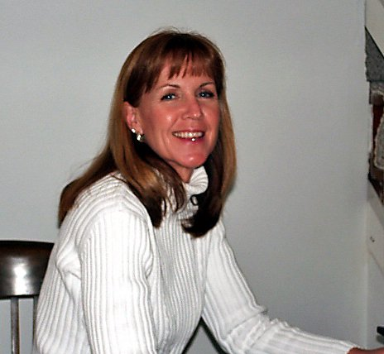
(Karen Stiles, Canal Winchester, Ohio)

Since 2007, Karen Stiles has been forging a path through the business and community networks in Canal Winchester. She’s become an advocate for women in business. She targets female-only organizations while also working for women within the confines of older, established male networks.

“If I were rich, this is what I’d do with all my time,” says Stiles, 53, of Canal Winchester, Ohio. Stiles spends the majority of her spare time on various committees and organizations in and around Canal Winchester, while working full-time for Bauers Financial Group as an Insurance Specialist/Client Services.

When she was laid off from her Senior Professor position at DeVry University in Columbus, Ohio, in 2007, there were no professorships open at local universities. Stiles found she had to reinvent herself in the business community, and she started networking and hasn’t looked back.

Stiles is a Board member of the Canal Winchester Chamber of Commerce, where she is Director of Ambassadors. This newly-created volunteer slot helps match an existing Chamber of Commerce member with a new member so that there is a connection for new members to find out useful information and to answer any questions.

“I’m also a member of the Downtown Business Owners Association, and a member of the Labor Day Festival Committee and Destination Canal Winchester,” says Stiles. “I love it. It’s so creative.”

In addition to committees, Stiles is a coordinator for the Canal Connections networking group that meets twice a month. “I’m really just the contact person. There is no President, just someone who starts the meetings, and we rotate that from meeting to meeting.”

Canal Connections is a local networking group that is open to one representative from a Canal Winchester business. Currently, Canal Connections has 22 members representing 22 businesses in Canal Winchester, such as banks, veterinary clinics, insurance agencies, construction firms, and electricians, even the local fitness gym.

“Canal Connections members usually speak about their businesses, and sometimes we have outside speakers come in. For example, our veterinary clinic member brought in their business coach who talked about things to do to improve business, like how to focus on your A, B, and C clients. Don’t spend time on your D and F clients.”

“I didn’t start Canal Connections though. My boss did with a Canal realtor.” Stiles downplays her role in coordinating the twice monthly meetings, but says it’s not an old boys’ network. The membership is about 50 percent female.

“We’re about helping businesses find business,” says Stiles.

<a href="http://www.wordle.net/show/wrdl/4952681/Women"
title="Wordle: Women"><img
src="http://www.wordle.net/thumb/wrdl/4952681/Women"
alt="Wordle: Women"
style="padding:4px;border:1px solid #ddd"></a>

One female networking group strictly for business women that Stiles belongs to is the local WOW group – Women of Winchester – that was started through the Chamber of Commerce. They meet one Friday a month for coffee.

“WOW is for women who own their own business to network together. We bring in speakers, but sometimes the speaker is from the group,” says Stiles.

At last Friday’s meeting, member Amanda Lemke talked about networking. “It was such a good meeting. She talked about ‘Is your net working? Or do you end up with a net of smelly fish?” says Stiles.

Stiles urges all women to join WOW. One doesn’t have to be a chamber member to join. “It’s just a group of really good women, very positive and supportive. Fun,” says Stiles.

For her latest venture, Stiles has teamed with several other women from Canal Winchester to create a new venue to bring women together.

“In May, we’re going to actually have our first Christian women’s conference called ‘Ordinary Women Can Make a Difference,’” says Stiles. “It will not be associated with any denomination.”

The conference is scheduled for May 19, 2012, from 10:00 a.m. until 4:00 p.m. at Harvest Christian Community Church in Pickerington, Ohio. There will be several motivational speakers with various breakout sessions for women to sit in and have a roundtable discussion.

“We’ll also have vendors, like various churches for those women who don’t have a church. Or help groups like an organization for battered women, another table for AA, organizations like that. Breakout sessions are going to be about helping ordinary women do extraordinary things all the time.”

Stiles speaks passionately about helping other women succeed in business, and she lives her beliefs.

“It’s not about competition. There’s enough business to go around. Canal Winchester is not like that. Overall, I want you to do well, just like I want our office to do well.”

* * * * * * * * * * * * * * * * * * * * * * * * *

ANALYSIS:

One technique I used to match my story with the intended publication/audience was to read two profiles done over the past several months for our weekly newspaper, The Times. I found their style to be very concise in aiming their piece at a certain angle, like the angle I took with my profile on Stiles helping women in business.

My own views, I’m sure, had some influence on my writing decisions because I am a woman who intends to start a business after graduation from OSU. I’m very interested in all of the organizations and associations that my profile on Stiles mentions, and now I feel I have a contact through Stiles.

